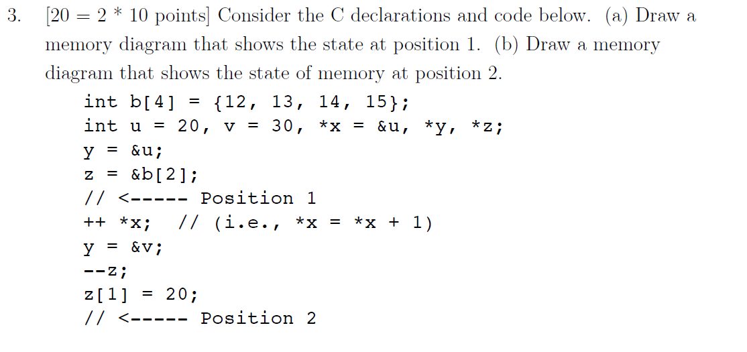

POSITION 1

|  |  |  |  |
| --- | --- | --- | --- |
| 12 | 13 | 14 | 15 |

B

U = 20

V = 30

x y z

POSITION 2:

|  |  |  |  |
| --- | --- | --- | --- |
| 12 | 13 | ~~14~~  **13** | ~~15~~  **20** |

B

U = ~~20~~ **21**

V = 30

x y z

/*Lab 04

Problem 1, 2 */

#include <stdio.h>

int main ()

{

int b [4]={2,4,2,8};

int *p, *q, *r;

p = &b[0];

q = &b[1];

r = &b[2];

printf(" %d", *p);

printf(" %d", *q);

printf(" %d \n\n", *r);

if (p == b);

printf (" a) means is true\n");

if (q == b + 1);

printf (" b) is true\n ");

if (q == (&b)+1);

printf ("c) is true\n ");

if (*q == *(r - 1));

printf ("d) is true\n ");

if (p[1] == r[-1]);

printf ("e) is true\n");

if (r-p == 2);

printf ("f) is true\n");

if (p != r && *p == *r);

printf ("g) is true\n");

if (q-b == &b[3] - &p[1]);

printf ("h) is true\n");

if (p < q && q < r);

printf ("i) is true\n");

// if (2*q - 2*p == 2); This is FALSE

// printf ("j) is true\n");

}